Power Electronics Lab

Department of Electrical Engineering

Course Name: Power Electronics and Drives Lab

Subject Code: EEC378



# IIT (ISM) Dhanbad Jharkhand - 826004

Name: Priyanshu Kumar

Admission No: 20JE0727

Title: Electric Light Dimmer circuit using SCR or TRIAC

Objective: To study the performance and waveforms of Electric light dimmer with resistive load.

Apparatus Required: -

|  |  |  |  |
| --- | --- | --- | --- |
| SI. No. | List of Equipment | Quantity | Specifications |
| 1. | AC Power Supply 220 V | ------------ | -------------- |
| 2. | Capacitor | 1 | 339nf Polyester film capacitor |
| 3. | DIAC | 1 | TYN604 – 600 V- 4A SCR- Thyristor |
| 4. | TRIAC | 1 | 6A4 6A 400V Silicon Rectified  Diode |
| 5. | Potentiometer | 1 | 10k to 100k, (0.5-6.0) Wattage |
| 6. | Bulb/Load Resistance | 1 | 10W,100 ohm |
| 7. | Mul meter | 1 | Mastech MS8233C Digital  Mul meter, AC-90 V |
| 8. | Digital Storage Oscilloscope | 1 | Singlent Technologies  SDS1052DL+ 50 MHz Digital Storage Oscilloscope |
| 9. | Wires | ------------ | ------------ |
| 10. | PCB | 1 | ------------ |

Theory:

A light dimmer regulates power flow to a resistive load, such as an incandescent light bulb, in an efficient way by allowing only a portion of the 60Hz current to pass through. Example current (and voltage) waveforms to a resistive load are shown in Figure 1 for firing angles α = 30º, 90º, and 150º. Firing angle is controlled by a potentiometer, RC circuit, and DIAC. The varia on of load power with α is shown in Figure 2.

Two important Characteristics of the light dimmer current are that -

1. it has zero average value (i.e., no DC, which minimizes corrosion of power grounds), and
2. it has half-wave symmetry (i.e., has no even-ordered harmonics).

The light dimmer circuit is designed for use at 120Vrms. However, the experiment is performed using an isolation on transformer and variac set at 90Vrms.

Light dimmer circuit and operation

The light dimmer circuit is shown in Figure 3. During each half-cycle, when the voltage across the capacitor (either positive or negative) exceeds the breakover voltage of the DIAC and “fires” the TRIAC, current then flows through the load. Once firing occurs, the voltage across the TRIAC collapses, the capacitor voltage goes to nearly zero, and the entire process resets at the beginning of the next halfcycle. For the circuit to work properly, a small current must flow through the load before firing occurs, but this current is miniscule with respect to full load current.

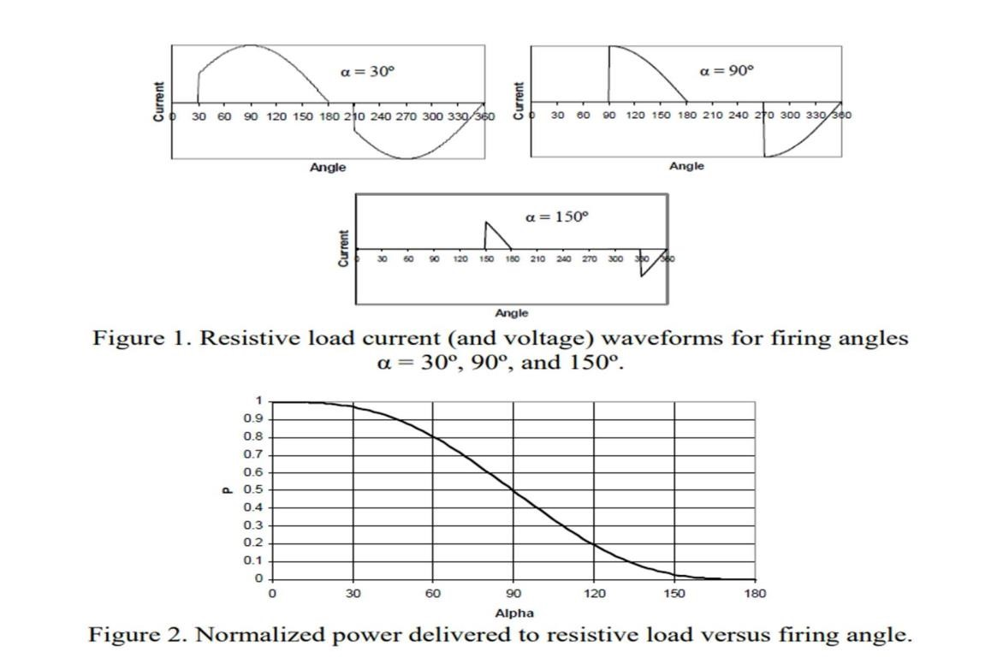

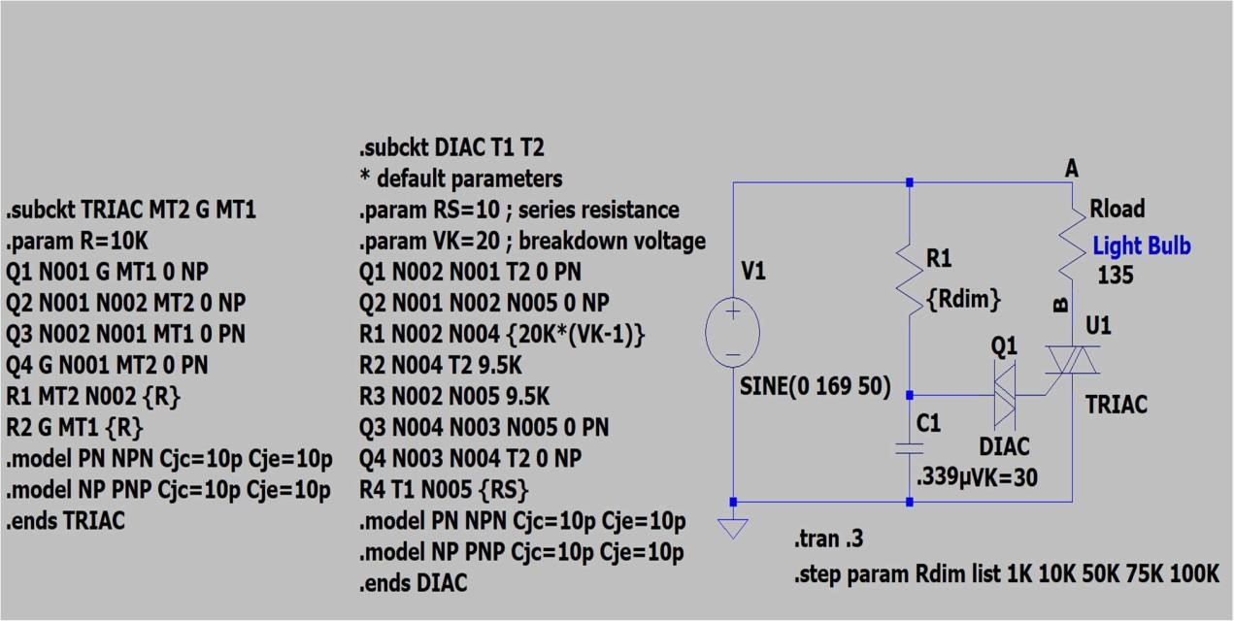

Figure-3 (Simula on Diagram)

# Procedure: -

1. Connect the circuit diagram of TRIAC light dimmer.
2. Switch on the supply and set the Variac voltage to 90V.
3. Connect the oscilloscope channel across the load terminals.
4. Vary a variable resistive pot(R) in steps gradually from minimum to maximum and observe the light bulb.
5. For each step measure the load R.M.S voltage.

# Observation Table:-

|  |  |  |  |  |  |
| --- | --- | --- | --- | --- | --- |
| SI. No. | Input Supply Voltage(V) | Firing  Angle(in deg) | Vrms(V) | Irms(A) | Power(in W) |
| 1. | 120.2 | 20 | 119.669 | 0.886 | 106.027 |
| 2. | 120.2 | 27 | 118.916 | 0.881 | 104.765 |
| 3. | 120.2 | 40.5 | 116.053 | 0.859 | 99.69 |
| 4. | 120.2 | 54 | 110.907 | 0.821 | 91.05 |
| 5. | 120.2 | 50 | 112.69 | 0.8347 | 94.06 |

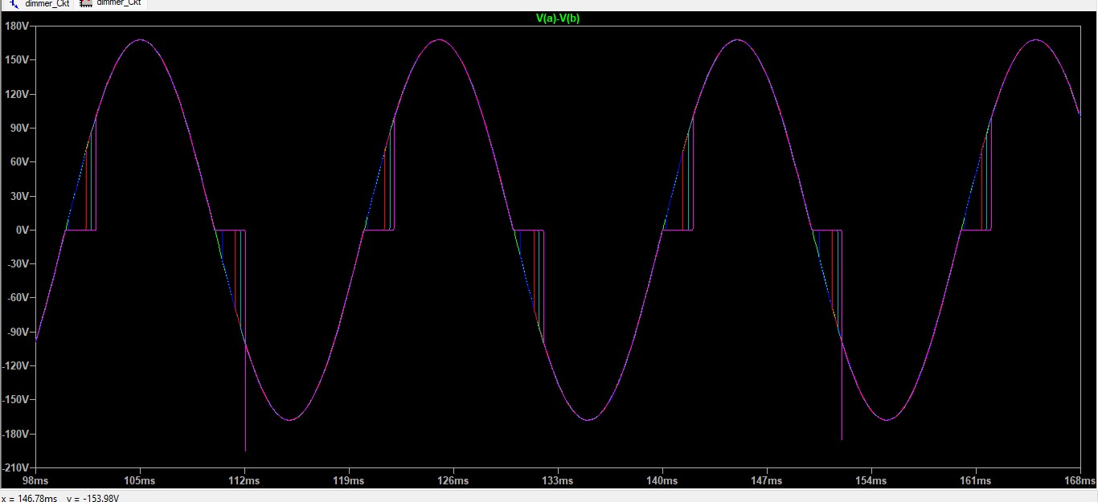

# Discussion:-

By varying the potentiometer knob, the firing angle varies ,hence the intensity of the bulb changes.

